US Strategies to promote economic growth & development in the low global growth era
Student Name
Institution
Date

An Outlook of the United States economy
The United States economy is amongst the top largest economies of the world. It attracts so much interest in terms of analytical study as well as economic outlook. The operation of successful economies is always relied on by other economies that aspire to up their game and live a level similar to these great performers (Francis, N. 2016). Basically, when an economy goes through a period of retardation of its systems or what is commonly known as depression, it has to revive itself, and in order to do this, strategies are drawn that are aimed at recouping and reinstating the anticipated state. The U.S. economy experienced a slowed economic growth during the low global growth era and this meant that its ability to compete in the global arena had been compromised. To come up with the best and effective strategies, the first step is usually focused on identifying the causes so that the cure can be developed.
The Body
The strategies that the economy has used to regain economic prowess are discussed in the below paragraphs. The first important factor is based on technological change. Technological innovation is regarded as an historic engine that the economy has relied on over the years to level up its economic growth and development. This factor has been in use up to date and its future its anticipations are enormous (Cline, R. 2008). Another vital factor that contributed to economic growth is high capital investment rates. The economy has been in a position to preserve a high-wages economy from high productivity. While looking into these mentioned factors, it is important to consider the policy framework to identify if it encourages or demotivates capital formation and innovation.
Adoption of new technologies
The U.S. economy reverted the nature of its manufacturing by adopting new technologies. The adoption of technology is has been a significant and a long term trend that impacted the information age within the economy at large. Technological impact was the precursor actor of the new Industrial Revolution.
In the United States, the real income growth rate per person has remained slightly below two percent per annum ever since the Civil War. This growth rate saw people’s living standards double despite the growth in population (Cline, R. 2008 & Bartik, 1995). Looking at the macroeconomic environment, the ability of the government to come up with wise policies in specified markets has not been fully achieved. The government is the primary institution that mandates systems and makes the environment of an economy to be favorable. It is the government that intervenes in coming up with interest rates and thus determining the cost of capita, something which is believed to have a lasting impact on the economy.
The American manufacturing industry grew more rapidly to courtesy of the technological advancement (Francis, N. 2016). It became more technologically sophisticated and the entire value chain was developed and it got to stand at a position where it could produce commodities that were cheaper in the foreign markets. Tis is to say that the economy achieved a competitive advantage that was made possible by the technological wave. Service sectors and especially the ones that are connected directly to information technology expanded. Strong and enduring economic growth requires high levels of investment. When resources are invested as opposed to their consumption, the economy makes a tradeoff between the preset moment and the future welfare.
Leadership and governance
There has been a huge ignorance in the American society concerning the forces which bring about economic growth (Nelson, G. 2017). Technology has been so much relied on and the people always thought that with technology, everything they aspired for in the economy would be achieved but that is not the case. Leadership and effective governance are so elementary in the growth and development of an economy. A quick economic growth that has to be sustained for longer durations of time has requires strong political leadership. The policy framework has to consider a growth strategy that can communicate the economy’s goals to the public and be able convince people that thrift, effort, and economic upheaval will yield. This is a strategy that encourages the people that they will succeed given that the government’s promises remain credible and factoring all people to reassure them and their children that they will share fruits of the growth. This is what most of the U.S. governments have strived to do in the time that it needed to reinstate its economy (Nelson, G. 2017). Leaders of the time have been patient with unwavering focus and a long planning horizon. The governments have tried to stabilize, privatize, and liberalize. The government’s coordination of policies through the understanding of the exact goals of the economy made it promote public goods like infrastructure that aided expansion. A strategy to provide safety nets or the people that are less involved or unwillingly excluded in the development agenda has been considered and it has helped in the growth of this economy. Better education systems were also provided that gave room for the development of a literate and intellectual society. This expanded research and constant improvement of existing systems in a bid to find solutions for the problems that people had to live with in their daily lives.
Tax manipulation
With the different states using a different tax combination to provide funds for government services, some states purely depend on income taxes while other recoup revenue from consumption taxes e.g. general sales taxes or excise taxes on selected goods (Rodrik, 2005). States are ranked as business friendly based on their tax compositions and criteria in the United States. Economic development is so much impacted by the tax structure of a given state and this is to mean that overall country tax structure which is determined from within the states impacts economic development. The reliance of a government to a specific tax benefits businesses as compared to when there is no a specified tax. A good example is property tax which is a burden to many capital-intensive companies compared to labor-intensive companies. This disparate effect within a tax structure comes up with incentives for the government to customize their tax structures for economic development goals.
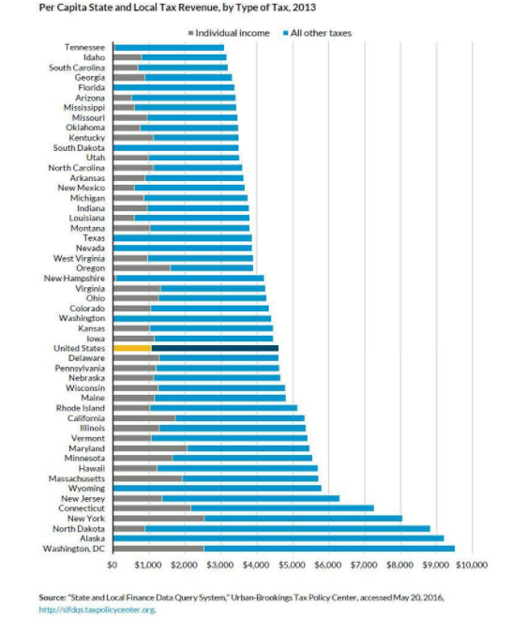
The United States government has used this technique to recoup as much as it could from its citizens despite the risks associated with the same. With an effective structure that factored every individual and businesses, the government managed to provide capital resources or the effective functioning of the systems of the economy (Nelson, G. 2017).
Other forms of taxation that were added into the system of the country include corporate income tax, property tax, sales and use tax. The corporate income tax provided about five percent of the government’s tax revenue. This was paid by large corporations, mostly operating in more than one state. Property tax is among the largest taxes in the U.S to date. Although it is considered as a local tax, it is an important economic development tool and especially for personal property tax. The government used this tax structure as an incentive for economic development and growth through valuation.
Conclusion
Economic development is hard to achieve. The hardest bit of it all is to maintain the economic growth because it means a reinvention of tricks, strategies, methodologies, and every other thing that is associated with development agenda of an economy. The U.S., being an economic power, still goes through hard times to capitalize and sustain its growth. This paper has critically looked into technological prowess, leadership & governance and the policy framework - key strategies that aided the development of the economy at a greater part. The GDP sustenance came into being because of the named and discussed strategies.

References
Bartik, T. J. (1995). Economic development strategies (No. 95-33). Upjohn Institute Working Paper.
Cline, R. (2008). Understanding the revenue and competitive effects of combined reporting. State Tax Notes, 48, 959-980.
Francis, N. (2016). Using the Tax Structure for State Economic Development. Washington, DC: Urban Institute. http://www. urban. org/research/publication/using-tax-structure-state-economic-development.
Nelson, G. (2017). John William McCormack: A Political Biography. Bloomsbury Publishing USA.
Rodrik, D. (2005). Growth strategies. Handbook of economic growth, 1, 967-1014.
Rodrik, D. (2005). Rethinking growth strategies. In WIDER Perspectives on Global Development (pp. 201-223). Palgrave Macmillan, London.

